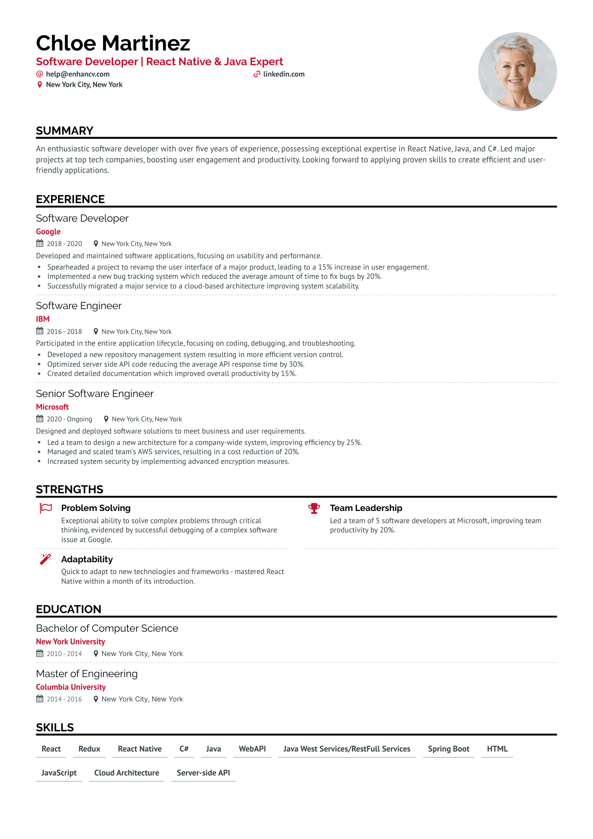
Chloe Martinez
Software Developer | React Native & Java Expert
@help@enhancv.com
New York City, New York
✔ linkedin.com
SUMMARY
An enthusiastic software developer with over five years of experience, possessing exceptional expertise in React Native, Java, and C#. Led major projects at top tech companies, boosting user engagement and productivity. Looking forward to applying proven skills to create efficient and user- friendly applications.
EXPERIENCE
Software Developer
Google
2018-2020
New York City, New York
Developed and maintained software applications, focusing on usability and performance.
•
Spearheaded a project to revamp the user interface of a major product, leading to a 15% increase in user engagement.
• Implemented a new bug tracking system which reduced the average amount of time to fix bugs by 20%.
Successfully migrated a major service to a cloud-based architecture improving system scalability.
Software Engineer
IBM
2016-2018 New York City, New York
Participated in the entire application lifecycle, focusing on coding, debugging, and troubleshooting. Developed a new repository management system resulting in more efficient version control.
·
• Optimized server side API code reducing the average API response time by 30%.
Created detailed documentation which improved overall productivity by 15%.
Senior Software Engineer
Microsoft
2020-Ongoing New York City, New York
Designed and deployed software solutions to meet business and user requirements.
•
·
Led a team to design a new architecture for a company-wide system, improving efficiency by 25%. Managed and scaled team's AWS services, resulting in a cost reduction of 20%. Increased system security by implementing advanced encryption measures.
STRENGTHS
Problem Solving
Exceptional ability to solve complex problems through critical
thinking, evidenced by successful debugging of a complex software issue at Google.
Adaptability
Quick to adapt to new technologies and frameworks - mastered React
Native within a month of its introduction.
Team Leadership
Led a team of 5 software developers at Microsoft, improving team productivity by 20%.
EDUCATION
Bachelor of Computer Science
New York University
2010-2014 New York City, New York
Master of Engineering
Columbia University
2014-2016
New York City, New York
SKILLS
React Redux React Native C#
Java WebAPI Java West Services/RestFull Services
Spring Boot
HTML
JavaScript Cloud Architecture Server-side API

